CSC 120 Lab 03

* (+15) **Install VirtualBox on your system.**

In this exerise you will be installing Virtual Box on your system. (Windows or Mac). After installing VirtualBox you will be using it for installing a linux operating system by creating a Virtual Machine in Virtual Box. (Read online about what a virtual machine is).

**VirtualBox Download link** <https://www.virtualbox.org/wiki/Downloads>

* (+15) **Explain what is a Virtual Machine**.

Why and how is are virtual machines used today?

Mostly used for having multiple systems operating on the same console at the same time

How does VirtualBox help you create Virtual Machine?

Virtualbox acts as a platform for running certain ISOs to emulate a different OS

What is the Host Operating System. How is it different from a Guest Operating System?

The Host Operating System is software using the underlying hardware. While the Guest Operating System is actually software that has been installed on to the machine to serve as “hardware.”

(**You can refer online** but **do not copy paste text** from blogs. It is very easy to detect and will undo the whole purpose of this assignment. I am not looking for a super technical answer but a general understanding of VM's. Write your own explanation here)

* (+20) **Install Ubuntu 20.04 as a virtual machine using VirtualBox.**

**Step 0:** Open VirtualBox on your machine.

**Step 1:** Download the ISO for Ubuntu 20.04 to install it using Virtual Box.**Ubuntu 20.04 ISO Download Link** [**https://ubuntu.com/download/desktop**](https://ubuntu.com/download/desktop)

**Step 2:** Read more about what an ISO is below. **Note:** You just need to download an ISO for this exercise and not burn or mount one,The links provided give a lot more details about ISO which may not be relevant for this assignment,*]*

**Reading :** [**https://www.lifewire.com/iso-file-2625923**](https://www.lifewire.com/iso-file-2625923)

**Step 3:** Follow the steps provided in the tutorial below to install Ubuntu 20.04 using VirtuallBox.

**Ubuntu installation Video link:** [**https://youtu.be/3qcK_Bwa0sU**](https://youtu.be/3qcK_Bwa0sU)

**Ubuntu Installation Screenshotslink:** [**https://itsfoss.com/install-linux-in-virtualbox/**](https://itsfoss.com/install-linux-in-virtualbox/)

**Note:** Although the above tutorial is for installating Ubuntu 17.04, the steps are still the same.

* (+10) **Open the terminal and type whoami. Paste the screenshot of the command and the output below.**

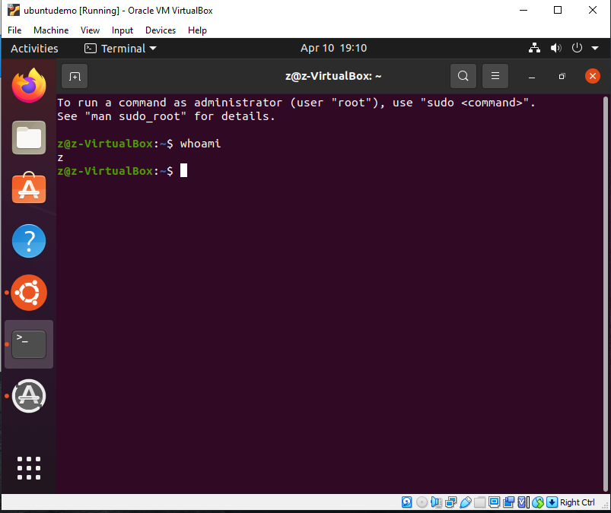

* **Conceptual Question**
* (+5) Explain the concept of a process. What is the difference between a process that is ready vs waiting?

A process is almost like a command, statement being made and being executed. Ready processes are being processed while waiting are standing in line for their turn.

* (+5) What is the distinction between application software and system software. Give an example of each.
  1. Application software is a certain program installed to run on the software, while system software is software that requires the computer to run. App = Google chrome, System = OS
* (+5) What is the difference between main memory and virtual memory?

Main memory is what is given on the computer hardware while virtual is created on the system software on as temporary or virtual memory.

* (+5) What are pages in virtual memory? Explain the concept of page size.

A fixed-length continuous block of virtual memory. The page size is based on the units of data being used to help store in a certain order.

* (+5) Summarize the booting process.

The computer hardware is turned on and the system starts its BIOs then loads the OS.

* What is the difference between an IO-bound process vs a compute-bound process?

An I/O Bound process is limited by the power of the CPU while the compute-bound process is based on the entire system power.

* (+5) If both IO bound and compute bound process are waiting for a time slice which (+5) process should be given priority? Why?

Usually you want to give the I/O bound process the priority so it can stop holding up the whole process of other system software trying.

* (+5) What problem arises when the lengths of time slices in a multiprogramming system are made smaller and smaller? What hapens when they are made longer and longer?

The processing time is fast and accurate when its small while larger it gets slower and less accurate.

* (+5) Explain the relationship between **semaphore**, **critical region** and **mutual exclusion.**

Semaphores are a sub-category for mutual exclusion. Mutual exclusion only allows one process inside the critical region.

**Instructions: Upload the file with the screenshot on Blackboard with youyr firstname_lastname.docx**